Instruction Class Exercise:
Step1:
If you have not installed Visual Studio Code. Go to Week 1> Live Meeting -1> and read follow the instructions:
Start Visual Studio Code:

Step 2:
Build a brand-new Java Project:
- From the File Menu, Select Open
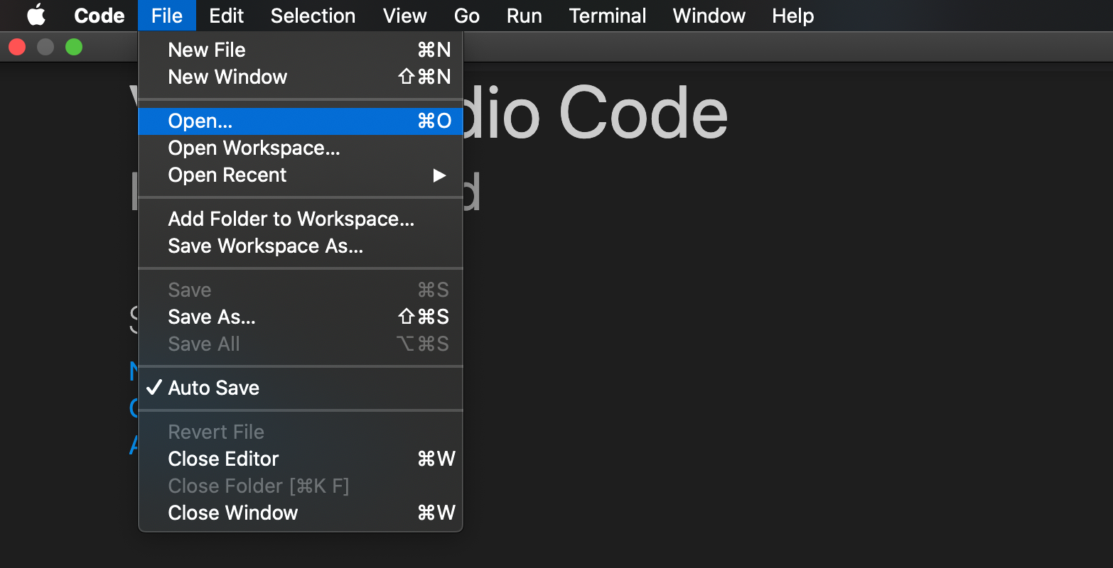
- Select a folder where you want to create your project
2
1

Click on the “New Folder” button: And type “Assignment1” and then click on the “Open”

- Your left File Folder Panel should look similar to the screenshot as follows:

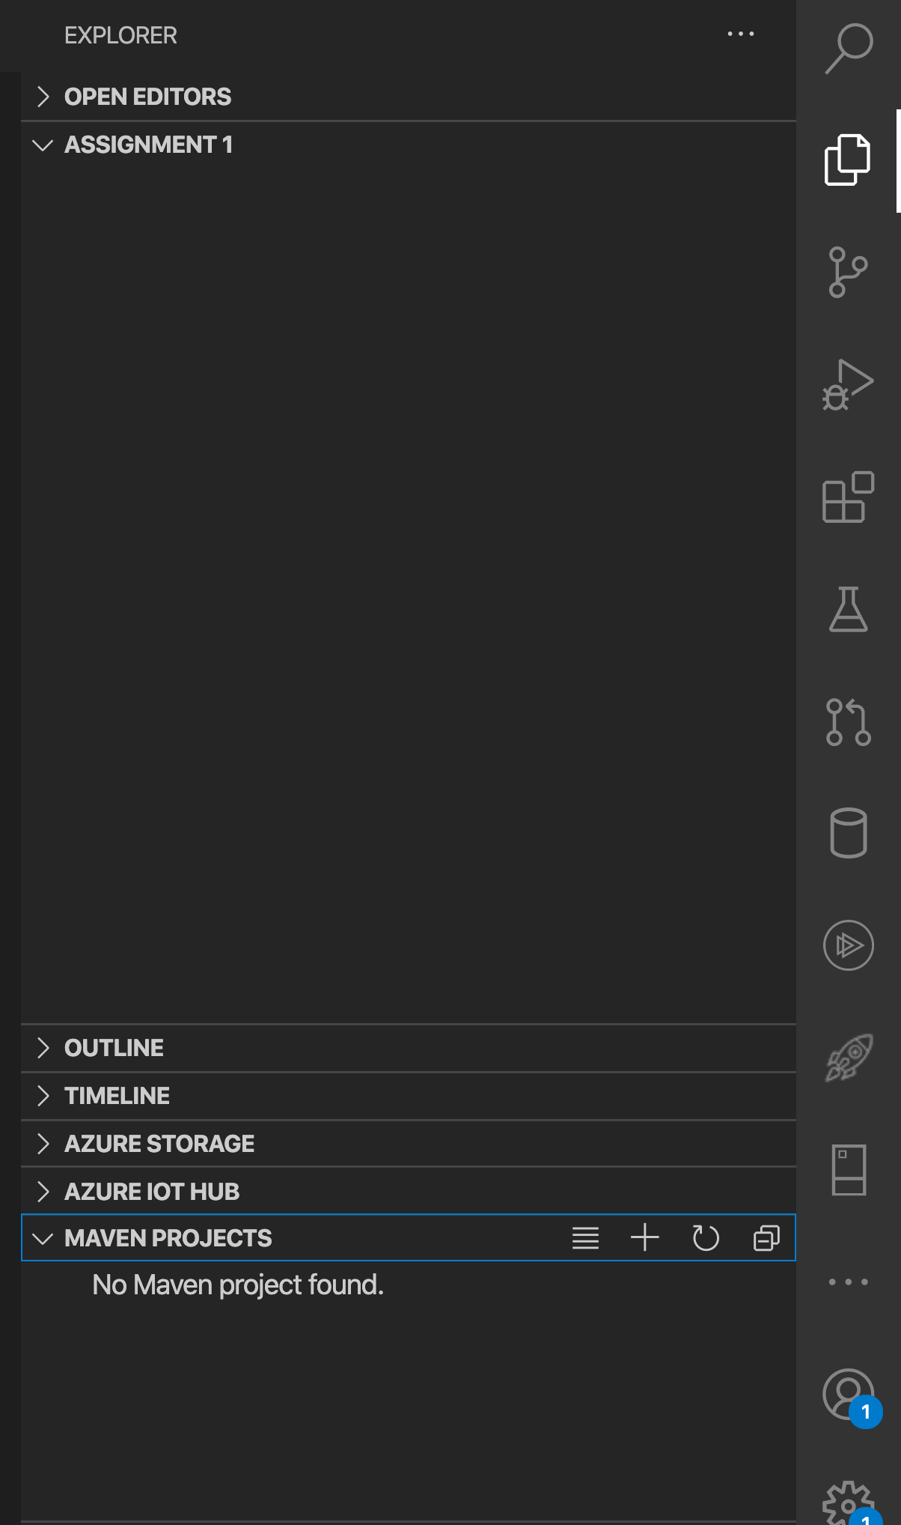
2
1: This is what it should look like in your VS Code

1
1: Select Maven Projects
2. Then Click on the + icon to create the projects

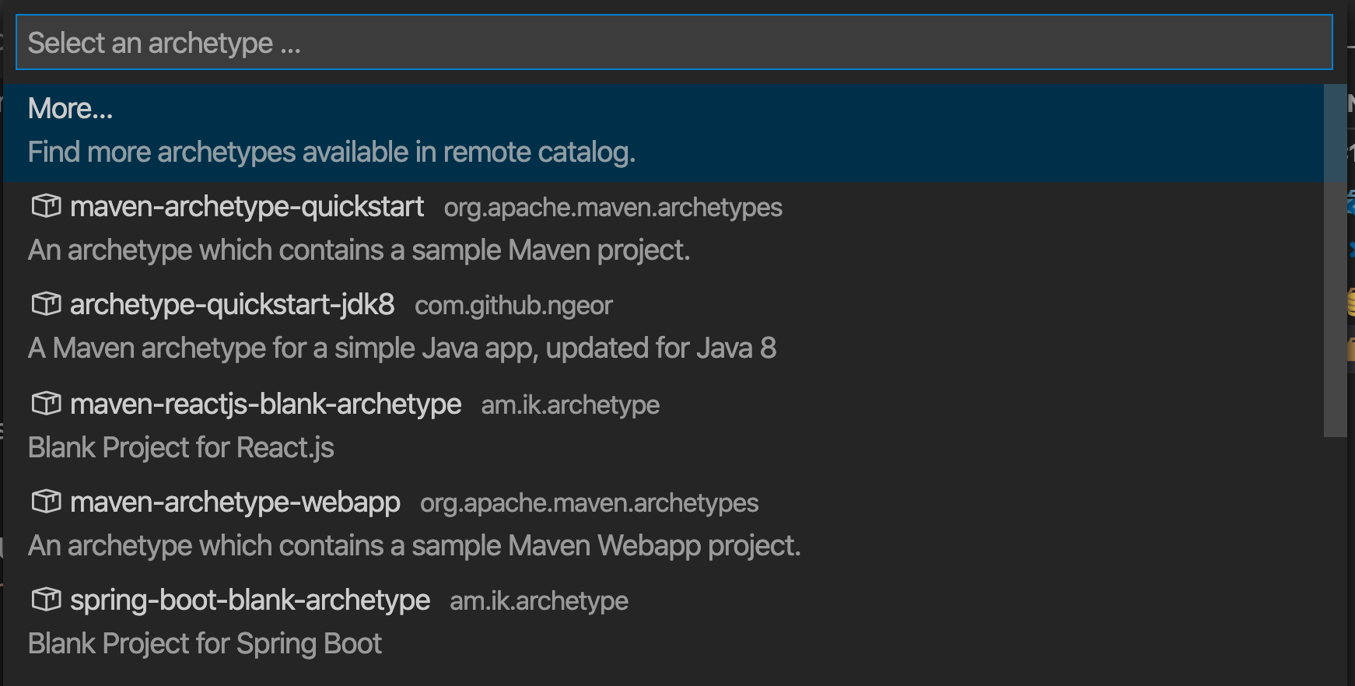
3
Select More

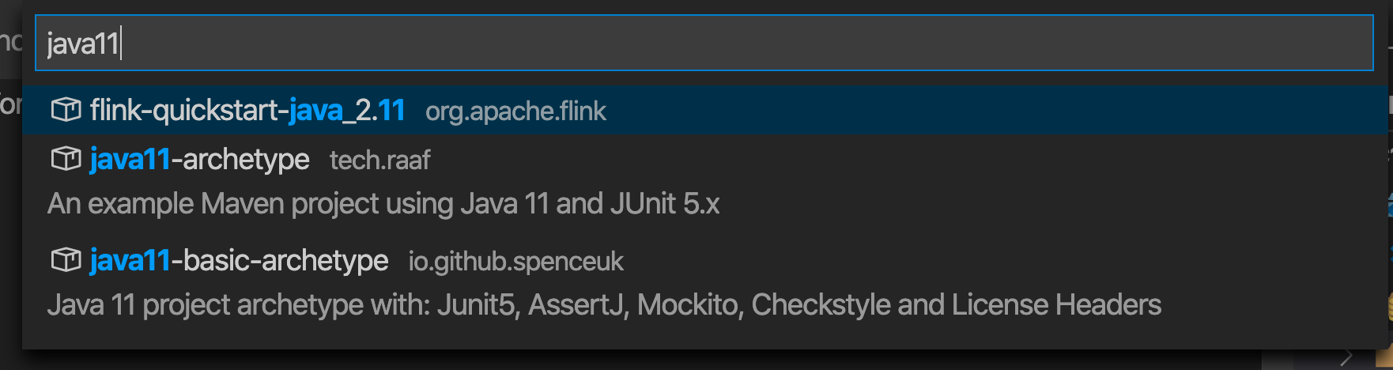
4
Type java11

5
Select: java11-archetype

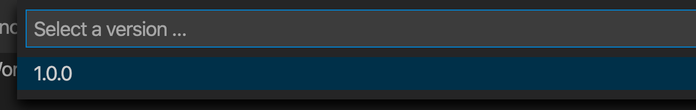
Select: 1.0.0 oh higher
6

7
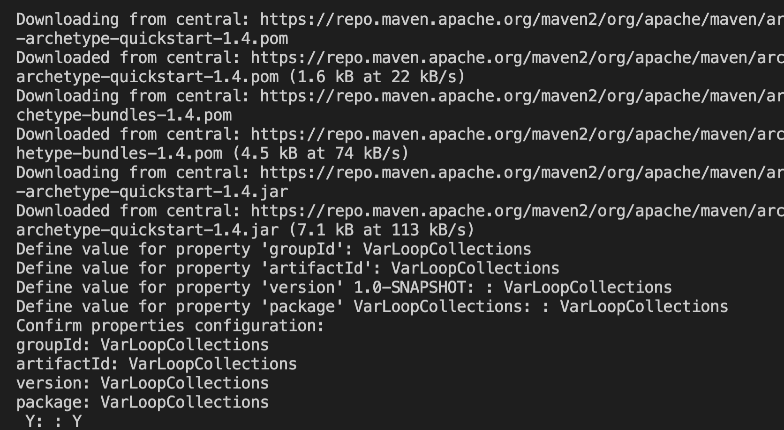

1: Enter VarLoopCollections: for ‘GroupID’
ArtifactId
Snapshot
And
package

The VS Code should look like the following
